Questions:
Q1: What is meant by Convolutional Neural Network?
Q2: Why is Convolutional Neural networks (CNN) preferred over Artificial Neural networks (ANN) for image data as input?
Q3: Explain the various layers in CNN.
Q4: Explain the importance of the RELU Activation function in Convolution Neural Network.
Q5: Why is the Pooling Layer used in CNN?
Q6: What is the size of the features map for a given input’s image size, filter size, stride, and padding amount?
Q7: If an input image is converted as a matrix size 12 X 12 with a filter size of 3 X 3 and stride of 1. Then, Find the size of the convoluted matrix.
Q8: What is meant by Valid Padding and Same Padding terms in CNN.
Q9: What are the types of Pooling?
Q10: Does the size of the feature map reduce by applying the filters? Explain why or why not?

Answers:
- What is meant by Convolutional Neural Network?
A Convolutional neural network (CNN, or ConvNet) is another type of neural network that can be used to enable machines to visualize things.
CNN’s are used to perform analysis on images and visuals. These classes of neural networks can input a multi-channel image and work on it easily with minimal pre-processing required.
These neural networks are widely used in:
- Image recognition and Image classification
- Object detection
- Recognition of faces, etc.
Therefore, CNN takes an image as an input, processes it, and classifies it under certain categories.
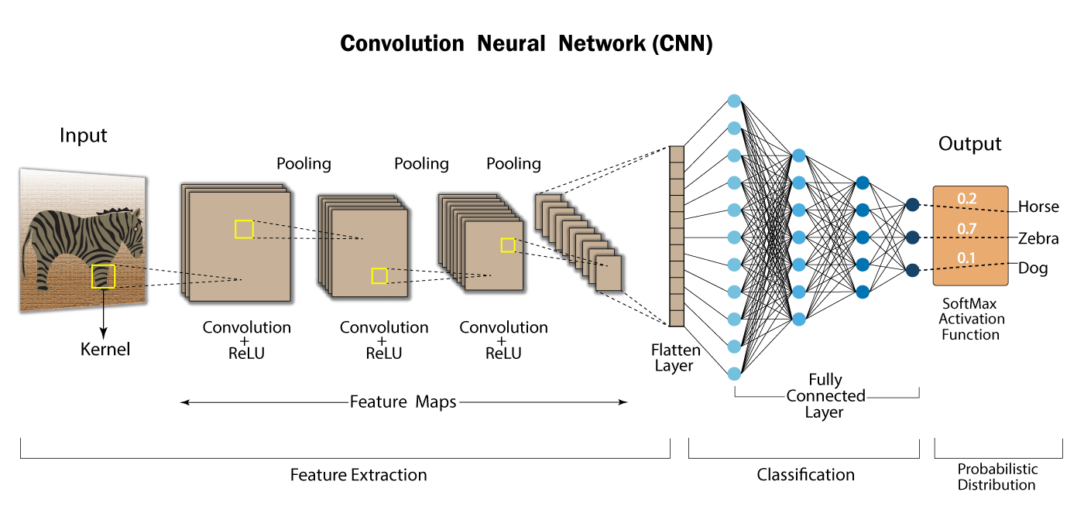

Why is Convolutional Neural networks (CNN) preferred over Artificial Neural networks (ANN) for image data as input?
Feedforward neural networks learns a single feature representation of the images but in the case of complex images, ANN fails to give better predictions, because it cannot learn pixel dependencies in the image.
CNN learns multiple layer feature representations of image’s by applying filters or by transformations.
In CNN, the number of parameters for the network to learn are lower than the multilayer neural networks as the units in the network decreases, hence reducing the overfitting chance.

Explain the various layers in CNN.
The layers involved in the architecture of CNN are:
1. Input Layer: The input layer in CNN contains image data. Image data is represented by a 3D matrix. This image is reshaped into a single column.
2. Convolutional Layer: This layer is to perform the convolution operations, creating several picture windows of smaller size over the data.
3. ReLU Layer: This layer introduces non-linearity to the networks and converts negative pixels to 0. The final result is a rectified feature map.
4. Pooling Layer: Pooling is a down-sampling operation which shrinks the feature map dimensionalities.
5. Fully Connected Layer: This layer identifies and classifes the object in the image.
6. Softmax / Logistic Layer: This is the last layer of CNN. It resides at the end of the Fully Connected layer. Logistic and Softmax are used for binary classification problem statement and multi-classification problem statement respectively.
7. Output Layer: This consists of the labels in the form of a one hot encoded vector.

4. Explain the importance of the RELU Activation function in Convolution Neural Network.
RELU Layer – The RELU operation is used after each convolution operation, It is a non-linear activation function. The operation is applied on each pixel and replaces the negative pixel values with 0 in the features map.
Normally, the image is highly non-linear in nature, that means varied pixel values. This is a situation where it is difficult for an algorithm to make correct prediction. RELU activation function is applied to decrease the non-linearity in these cases.
This layer also helps in the feature detections, decreasing the image’s non-linearity, and conversion of negative pixels to zero that allows detecting variation of features.
Thus, Non-linearity in convolution is introduced by a non-linear activation function like RELU.
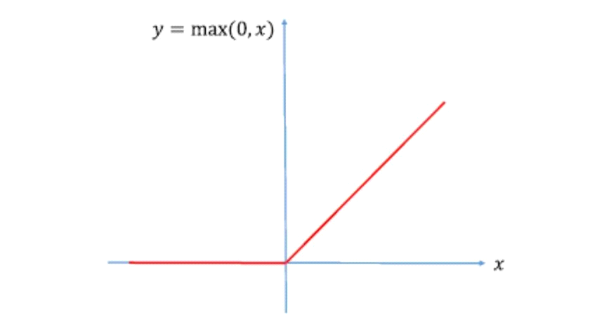

Why is Pooling Layer used in CNN?
Pooling layers are used to decrease the input image’s size so that it increases the speed of network’s computation.
Pooling/spatial pooling layers:
Also known as sub-sampling or down sampling.
Applied after convolution and RELU operations.
Reduces the dimensionality by retaining the most important information of each feature map as the hidden layer’s required in learning the complex relations in the image are large.

What is the size of the features map for a given input’s image size, filter size, stride, and padding amount?
Stride explains about the number of pixels we need when we are convolving filters.
If, size of input’s image is n x n,
size of filter is f x f,
p is the padding amount and
s is the Stride
Then the dimensions of a feature map is:
Dimension = floor [ ((n-f+2p)/s) +1] x floor [ ((n-f+2p)/s)+1]

If an input image is converted as a matrix size 12 X 12 with a filter size of 3 X 3 and stride of 1. Then, Find the size of the convoluted matrix.
We use the generalized equation to calculate the size of the convoluted matrix:
C = ((n-f+2p)/s)+1
where,
C – size of the convoluted matrix
n – size of the input matrix
f – size of the filter matrix
p – padding amount
s – Stride applied
From the question it is given, n = 12, f = 3, p = 0, s = 1
Hence, the convoluted matrix size is 10 X 10.

What is meant by Valid Padding and Same Padding terms in CNN.
Valid Padding: It is used when there is no padding requirement. The output matrix after convolution will give the dimensions of (n – f + 1) X (n – f + 1).
Same Padding: In this, elements of padding are added all over the output matrix. After padding, the dimensions for the input matrix are the same as that of a convolved matrix.

What are the types of Pooling?
Spatial Pooling can be of different types – max pooling, average pooling, and Sum pooling.
Max pooling: Once we obtain the feature map of the input, we will apply a filter of determined shapes across the feature map to get the maximum value from that portion of the feature map. It is also known as subsampling because from the entire portion of the feature map covered by filter or kernel we are sampling one single maximum value.
Average pooling: Computes the average value of the feature map covered by kernel or filter, and takes the floor value of the result.
Sum pooling: Computes the sum of all elements in that window.

Does the size of the feature map reduce by applying the filters? Explain why or why not?
No, the convolution operation reduces the matrix of pixels i.e., input image, if the size of the filter is greater than 1 (f > 1).
When a filter of 1×1 is applied, then there is no size reduction of the image and thus, no information loss.

